**What are inputs and outputs?**

The goal of training is to improve a model so that it can make high-quality estimations or predictions. Once trained, you can use a model in the real world like normal software.

Models don't train themselves. They're trained using data plus two pieces of code, the *objective function* and the *optimizer*. Let's explore how these components work together to train a model to work well.

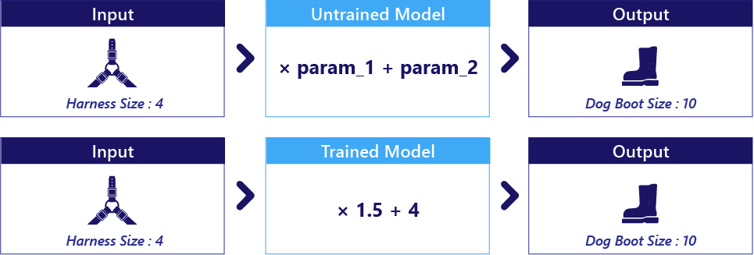

**The Objective**

The Objective is essentially what we want the model to accomplish. In machine learning, the objective is defined in terms of specific tasks we want the model to perform. For example, if we want to estimate a dog's boot size based on its harness size, that's our objective.

To translate this objective into something a computer can understand, we use an objective function (also known as a cost function or loss function). This function evaluates how well the model's predictions match the actual outcomes. For instance, if the model predicts a boot size, the objective function will calculate how close this prediction is to the real boot size. The objective function guides the model during training by providing feedback on its performance, which the model then uses to improve.

**The Data**

Data refers to the information we provide to the model to help it learn. There are two main types of data involved:

* Inputs: These are the features fed into the model to make predictions. In our scenario, the input is the harness size of the dog.
* Labels/Target: This is the actual result we want the model to predict, which the objective function uses to assess the model's performance. For example, the actual boot size of the dog.

During training, we provide both the inputs and the correct answers (labels) to the training algorithm. This helps the model learn from the data and improve its predictions.

**The Optimizer**

The Optimizer is an algorithm that adjusts the model’s parameters to minimize the error calculated by the objective function. It does so iteratively, making small adjustments to the model's parameters to improve its performance.

Here’s a simplified overview of the process:

* The model makes a prediction based on the input data.
* The objective function evaluates the prediction and calculates the error.
* The optimizer adjusts the model’s parameters to reduce this error.

Optimizers can be quite complex, involving advanced mathematics and algorithms. However, in practical applications, we often use pre-built optimizers from machine learning libraries (like TensorFlow, PyTorch, etc.), so we don't have to write them from scratch.

**Putting It All Together:**

1. Objective Function: Defines what success looks like for the model.
2. Data: Provides the model with examples to learn from.
3. Optimizer: Iteratively improves the model’s parameters to achieve the objective.